Münchener Str. 48
D-60329 Frankfurt
Tel: 069/ 900 281 - 10
Fax: 069/ 900 281 - 99
info@attac.de
www.attac.de

Frankfurt, March 10, 2005

Attac Deutschland, z. Hd. Günter Reinhard
Münchner Str. 48
D-60329 Frankfurt
Attac Deutschland. Münchener Str. 48. 60329 Frankfurt

<F> <G>
European Parliament
<N> <O>
60, rue Wiertz / Wiertzstraat 60
B-1047 Bruxelles/Brussel

Dear <J> <G>!

With concern we have been following the current negotiations regarding a European service directive. The European Commission’s proposal from the beginning of 2004 for a directive concerning services on the domestic market marks the biggest liberalisation plans of the European Union so far. Nearly all services, including services of general economic interest, are affected by the plan and will be deregulated all at once.

In particular the Country of Origin Principle (article 16) is to be deprecated as it will undermine an effective prudential economic supervision and initiate a merciless dumping competition. Furthermore, the directive deeply interferes with competencies on federal, state and municipal levels. Concerning this, the German Federal Council clearly stated that the commission’s directive is a breach of the tenets of subsidiarity, commensurability, and that the Country of Origin Principle is not backed by the European Community Contract.

We are especially criticising the following points of the draft:

- The directive covers all paid services, consequently all public services which require fees for their utilisation. These include water supply and sewage treatment plants, nursery schools, hospitals, adult education centres, and universities. The European commission blatantly extends its influence on social security-regulated health and care services as well as on radio stations.
- According to article 14, member states will not be allowed to dictate the form of the subsidiary. They will not be allowed to demand that service providers have to be active for a minimum amount of time on their territory or that they have to be recorded in business registers.
- The member states have to subordinate numerous regulations to a mutual review. Article 15 names demands regarding the legal form, fixed minimum prices, and admittance limits. This influences the choice of organisational forms for municipal tasks, which ensure the democratic control authenticated by law. Likewise, advantages for non-profit-making companies can be put to test, which would penalise public utility privileges. Furthermore, dumping prohibitions would come under pressure and a ruinous predatory pricing is foreseeable in many industries.
- According to article 15, new law and administrative regulations must, already in their draft state, be presented to the Commission and may only be implemented with its endorsement. With this article the commission virtually places the member states under custodianship.
- According to the Country of Origin Principle, service providers are solely subject to the regulations of their country of origin. Inspections through the authorities of the destination country will have to cease altogether. However, even if the Land of Origin was authorised to conduct inspections outside the realm of its state territory, it would have neither an excessive interest in, nor the capacities to inspect the foreign businesses of the companies based in it. Through this emerges a law-free room!
- The German national association of building industries further points out, that the directive concerning the posting of workers (96/71/EC) which should ensure a fair cross-border competition, will be undermined by the restricted means of control of the destination country, and that article 25, which regulates the posting of workers from third countries, will inevitably lead to a considerable rise of illegal cross-border and undeclared employment.3
- With the Country of Origin principle, in each member state up to 25 different legal forms relating to business, tariffs, and social legislation will be competing with each other. Service providers of those member states will be in advantage over others, whose states have the lowest standards in concerning the control of companies, qualification requirements, quality, quality control, taxation, employment conditions, environmental and/or consumer protection. This is an enormous incentive for the displacement of registered offices and for the foundation of letterbox companies. As a result we would experience a merciless dumping competition.

We oppose social achievements in the European Union being reduced to a minimal standard by this directive. It is scandalous how in this case the most heavily-weighted decisions are pressed through without any serious public debate, under the obvious pressure of a powerful economic lobby. We need independent investigations of the social and democratic consequences of this planned service directive. We are afraid that the threatening cross-border competition over the lowest standards endangers European community and will give rise to right extremist powers. Therefore, we call on you to act decidedly against the adoption of this directive.

We look forward to a response with great interest. Furthermore, we would like to refer you to our website (ww.attac.de/bolkestein) where you can find further information.

With best regards
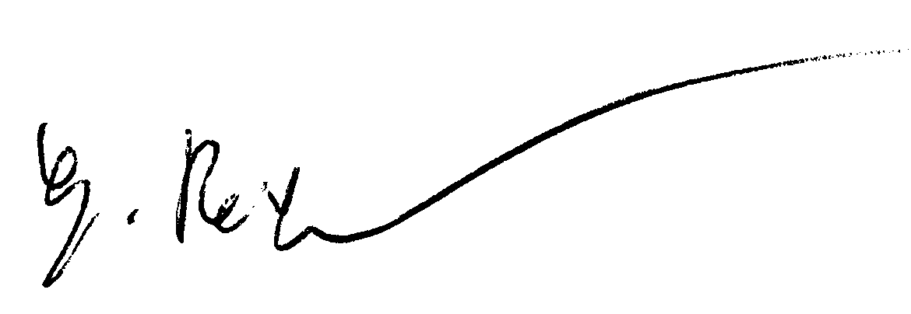
Günter Reinhard, attac Marburg

Proposal for a directive of the European Parliament and Council concerning internal market services. Brussels, 25.02.04, KOM(2004) 2 endg.
Resolution of German Bundesrat, 02.04.04, Drucksache 128/04, bordernumber 5 and 6, but also 39.
3 Statement of the National Association of Buildung Industry, 28.10.04, page 2f.

